# Online Movie Ticketing System

The Online Movie Ticketing System, named MovieMagic, is a web application developed using the Django framework in Python. This project serves as part of the Business Application Development module at the Faculty of Business, University of Moratuwa. To get started, users need to install the required dependencies using the pip package manager. The primary dependencies are Django and Pillow, with Django being the core web framework for the application, and Pillow providing image processing capabilities.

Once the dependencies are installed, users can proceed with database setup and migration by executing the `py manage.py migrate` command. After successfully setting up the database, the local development server can be initiated using the `py manage.py runserver` command. Users can then access the MovieMagic web application by navigating to "http://127.0.0.1:8000" or "localhost:8000" in their web browser.

The web application includes an Admin Panel for managing the system, and the provided credentials for accessing the Admin Panel are username: "Nithi1999" and password: "MovieMagic99". The project was originally created by Pahirathan Nithilan and has been modified by T.Viploon, T.Akulapiriyan, and W.Robina, each contributing to the development and enhancement of the application.

# About this project

In the MovieMagic project, we have developed a comprehensive Online Movie Ticketing System using the Django web framework. This system provides users with a seamless platform to explore and book movie tickets online. The website is structured with various views, each serving a distinct purpose. The "index" view showcases the currently available movies, while the "upcoming" view displays movies that will be released in the future.

For user interaction, we have implemented a user authentication system with a login and signup functionality. Users can register for an account through the "signup" view, providing essential details such as email, name, mobile number, age, and the number of seats they wish to book. The registered users and their booking information are stored in the database, and the booked tickets can be viewed through the "booked" view.

Detailed information about each movie, including its name, image, release date, duration, genre, language, rating, cast, trailer link, and pricing, is available on the "details" and "updetails" views. Users can navigate to these views to get more insights into their favorite movies.

Additionally, the project includes an "about" page that provides more information about the MovieMagic system. This page serves as a space to communicate the project's background, its purpose, and any additional details that users may find interesting.

The project's architecture is structured to be easily manageable through the Django admin panel, where administrators can oversee and manipulate movie details, user registrations, and other essential aspects of the system.

Overall, MovieMagic aims to streamline the process of booking movie tickets, offering users a user-friendly interface to explore, select, and reserve tickets for their preferred movies.

# Database

The MovieMagic project utilizes a SQLite3 database to manage and store essential data for seamless functioning. The database consists of three main tables, each corresponding to different aspects of the movie ticketing system.

The "movies" and "movies2" tables store details about the movies available in the system, including information such as the movie name, release date, duration, genre, language, rating, cast, trailer link, and pricing. The tables are designed to accommodate both currently playing movies and upcoming releases, allowing for a dynamic and flexible representation of the available film catalog.

The "reg" table is dedicated to user registration and booking information. It stores user details, including email, name, mobile number, age, and the number of seats booked. This table facilitates the tracking of user bookings, enabling users to view their reserved tickets through the "booked" view.

The database structure aligns with the Django models defined in the "models.py" file, ensuring a consistent and organized representation of data. This relational database system plays a crucial role in maintaining the integrity of the MovieMagic system, enabling efficient data retrieval and management through Django's powerful ORM (Object-Relational Mapping) capabilities.

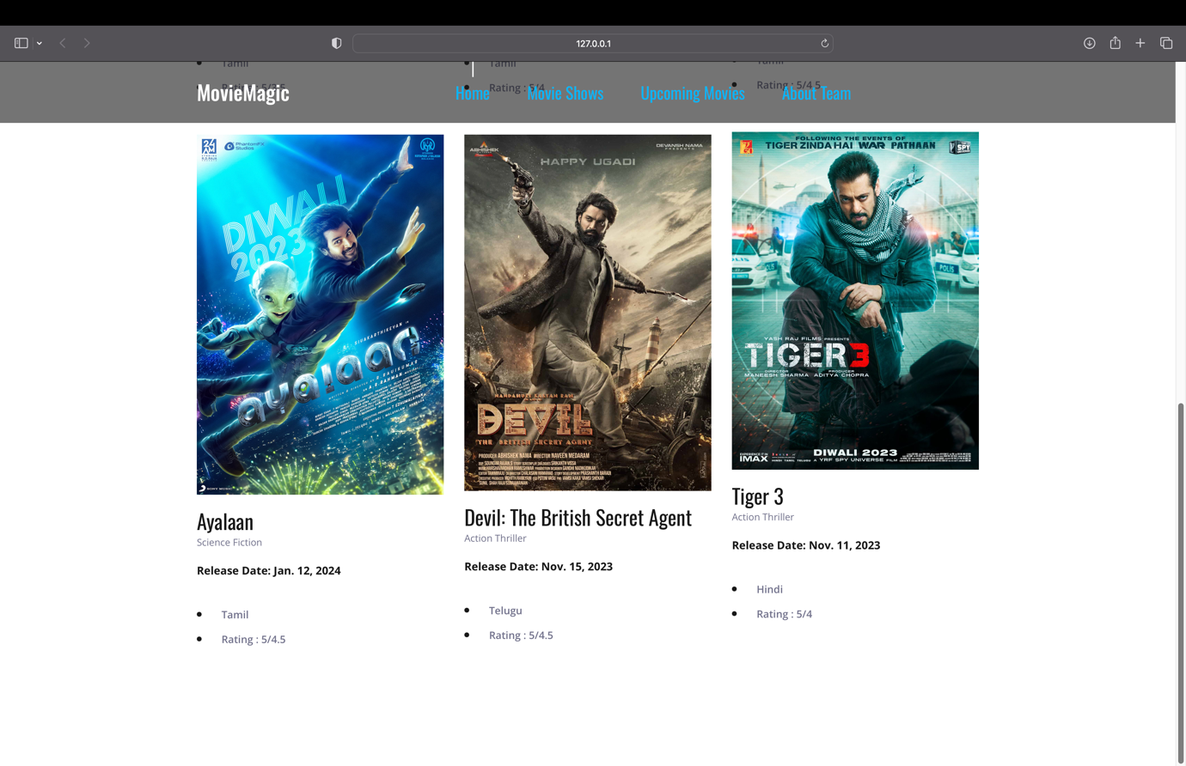

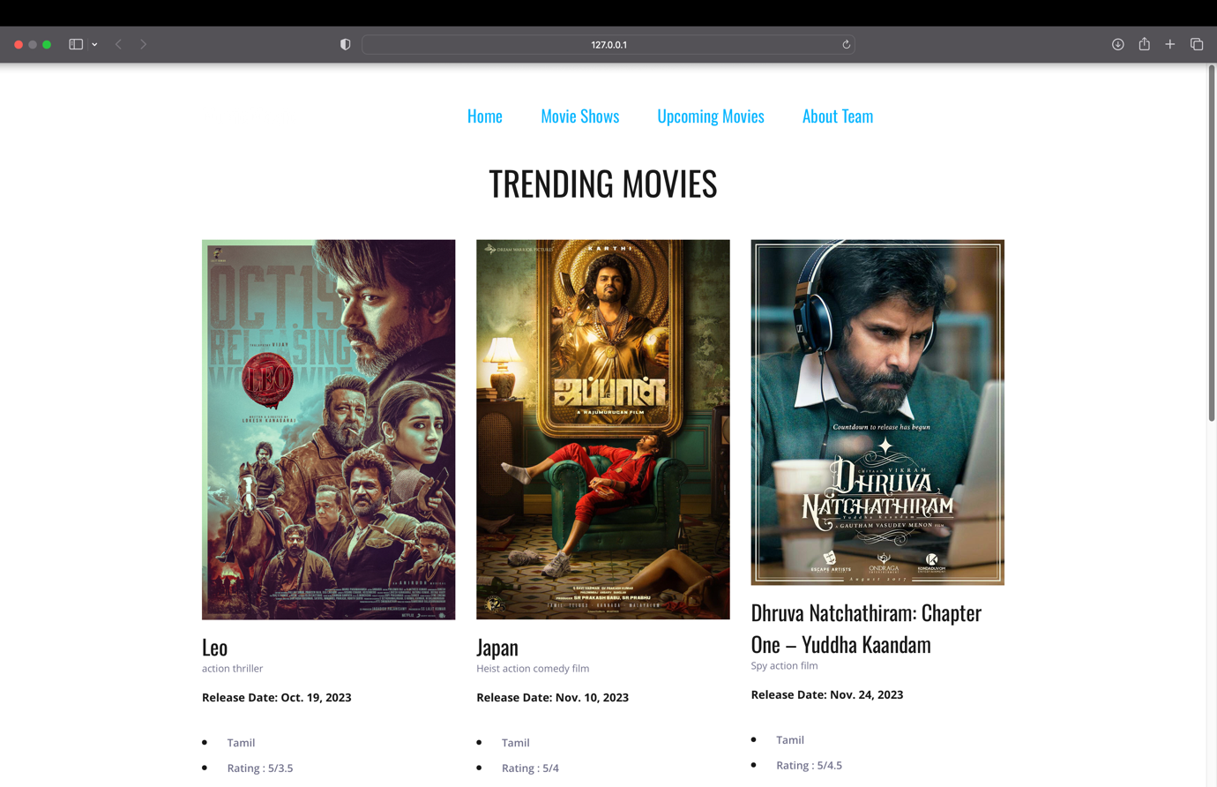

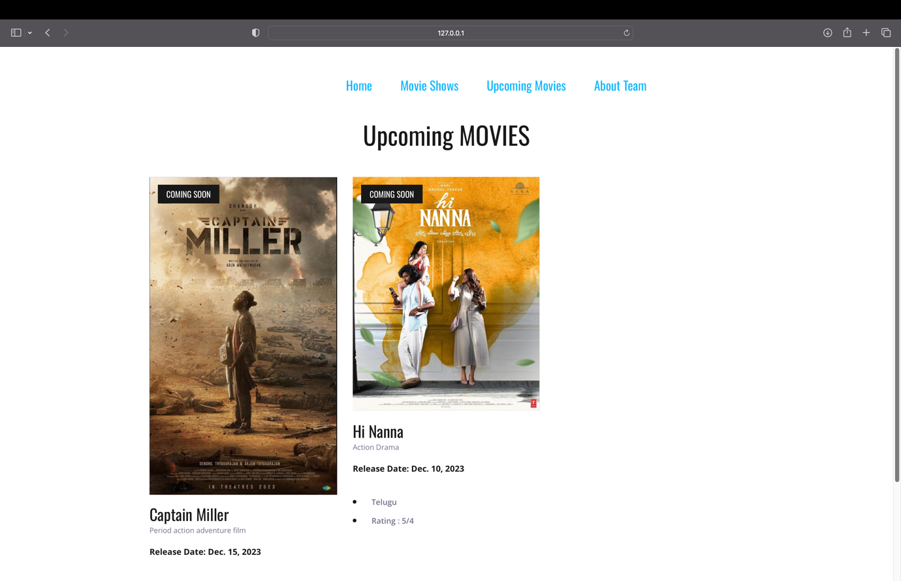

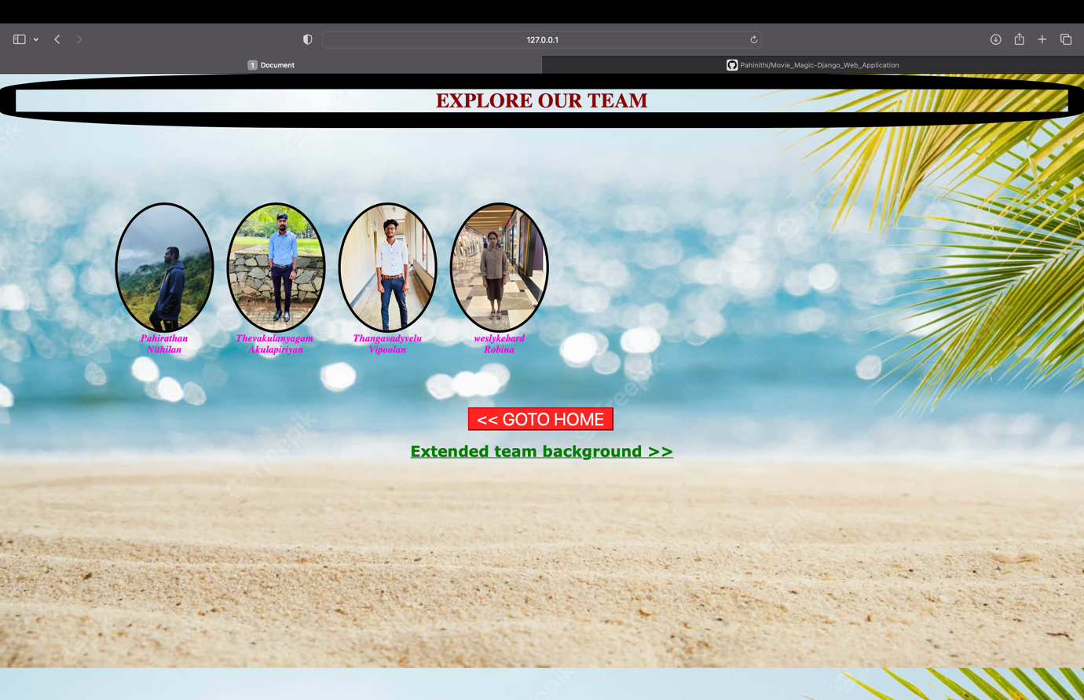

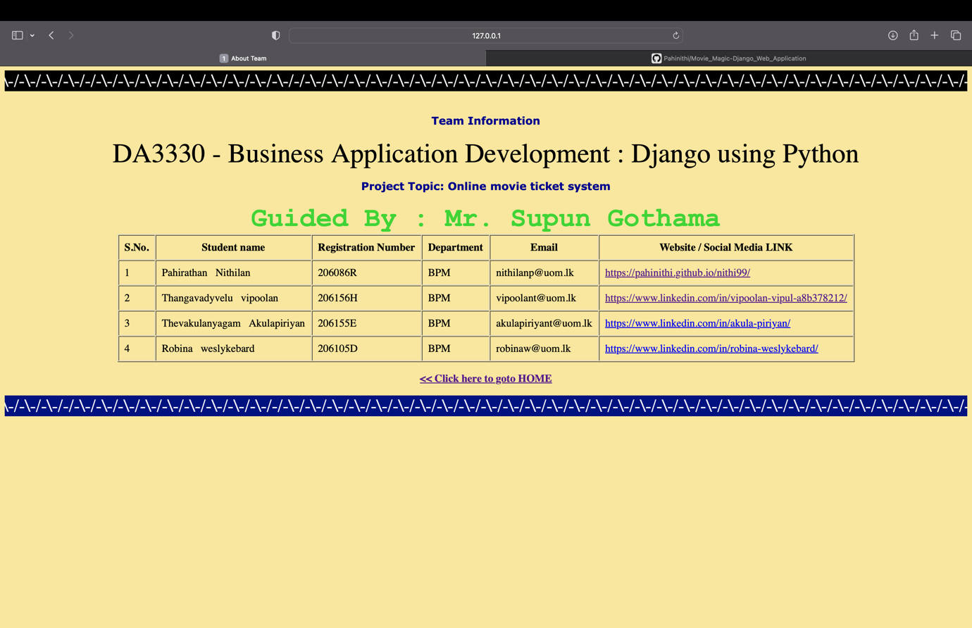

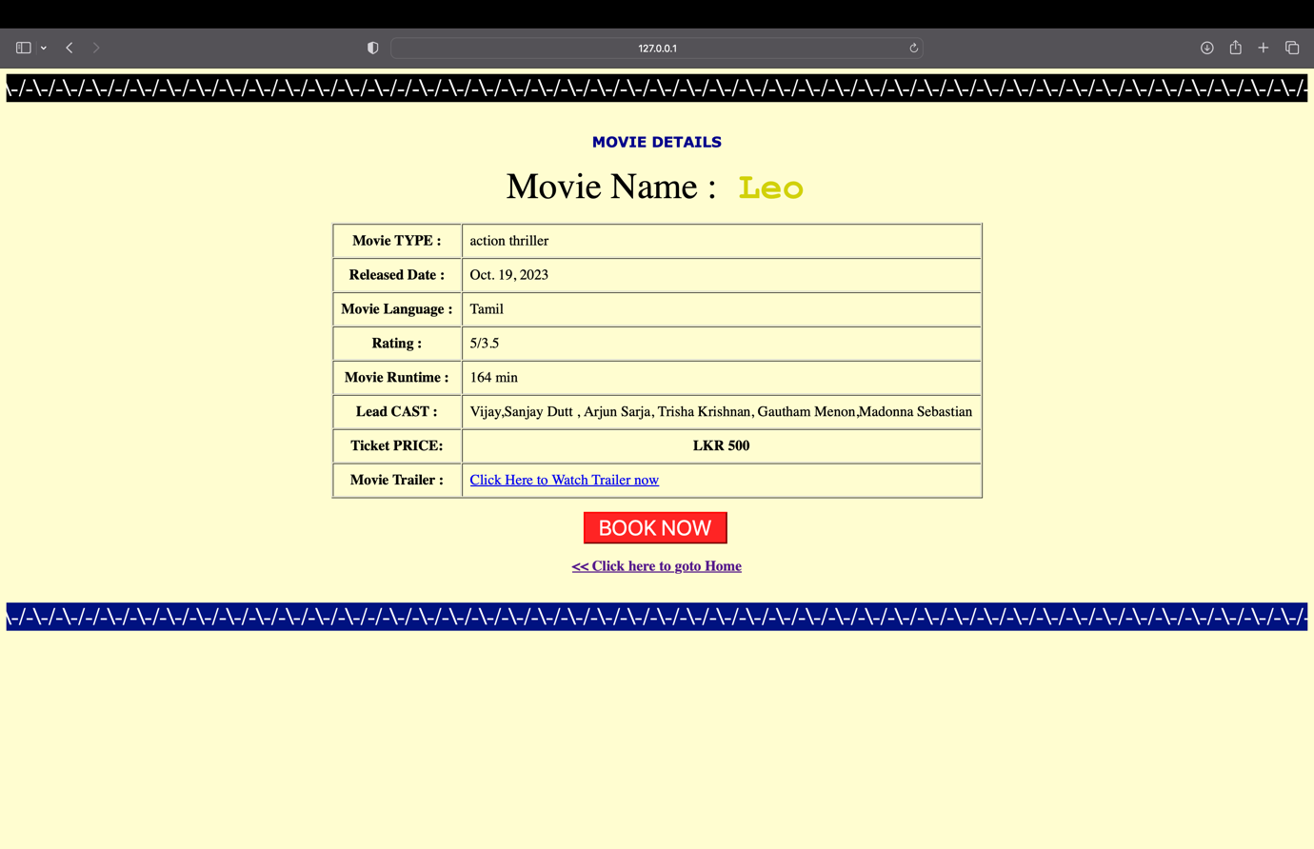

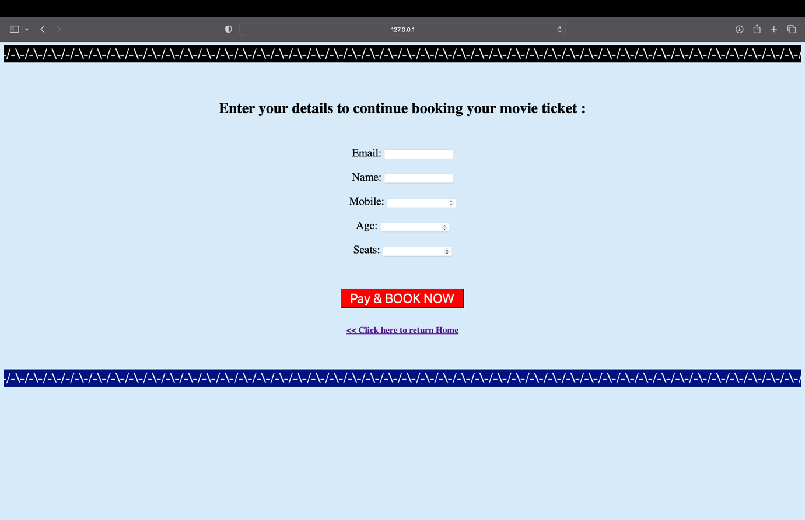

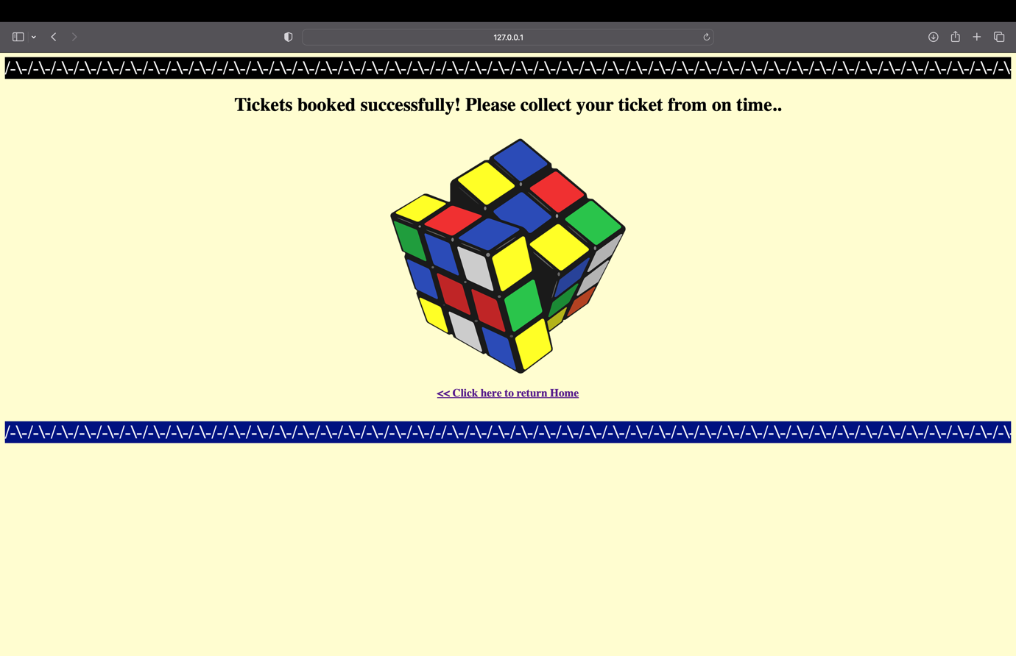

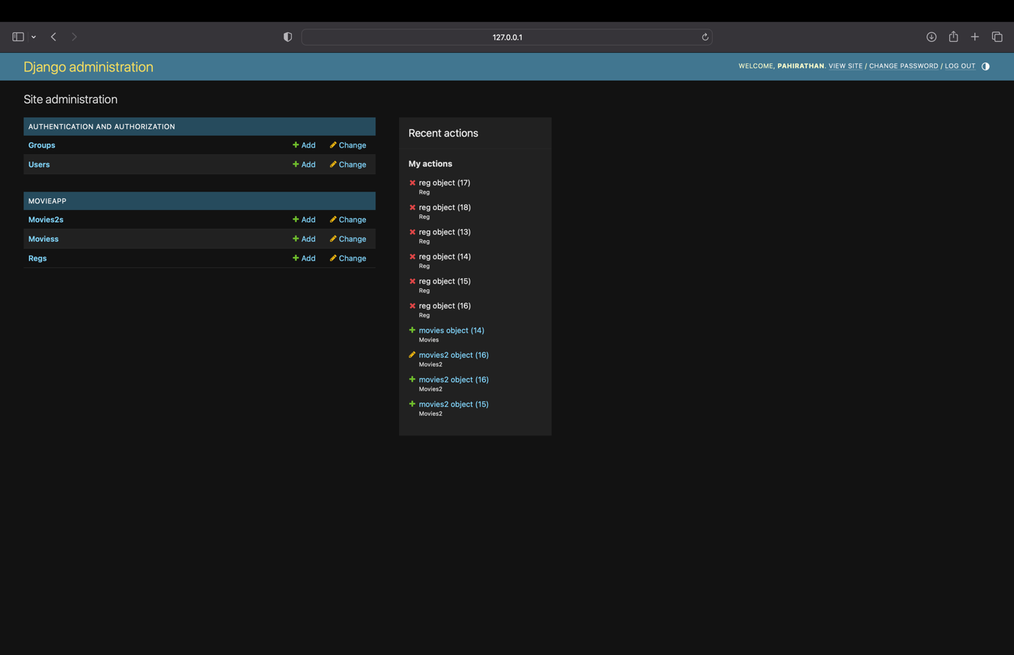

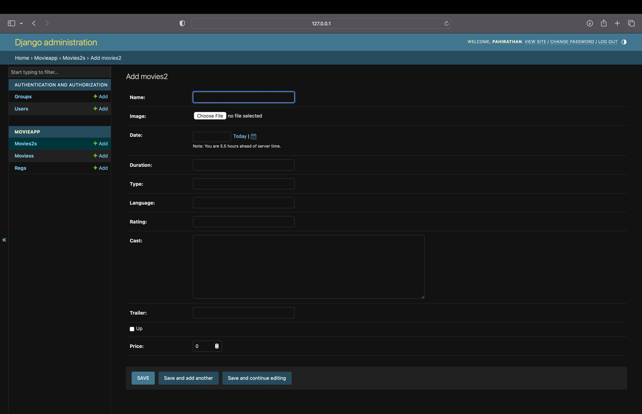

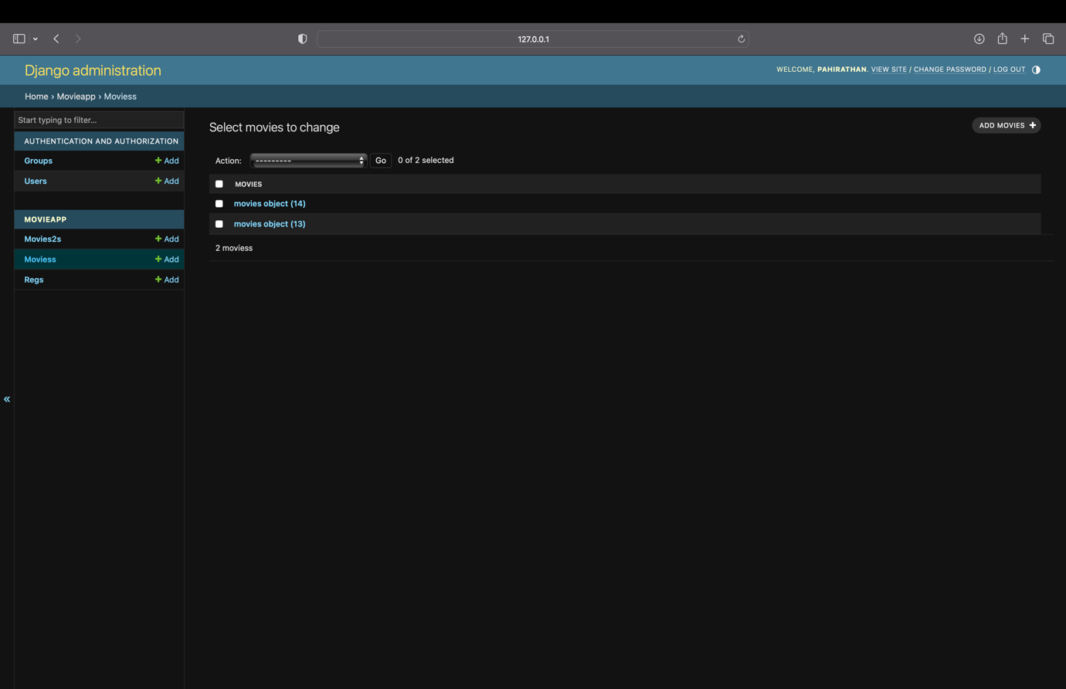

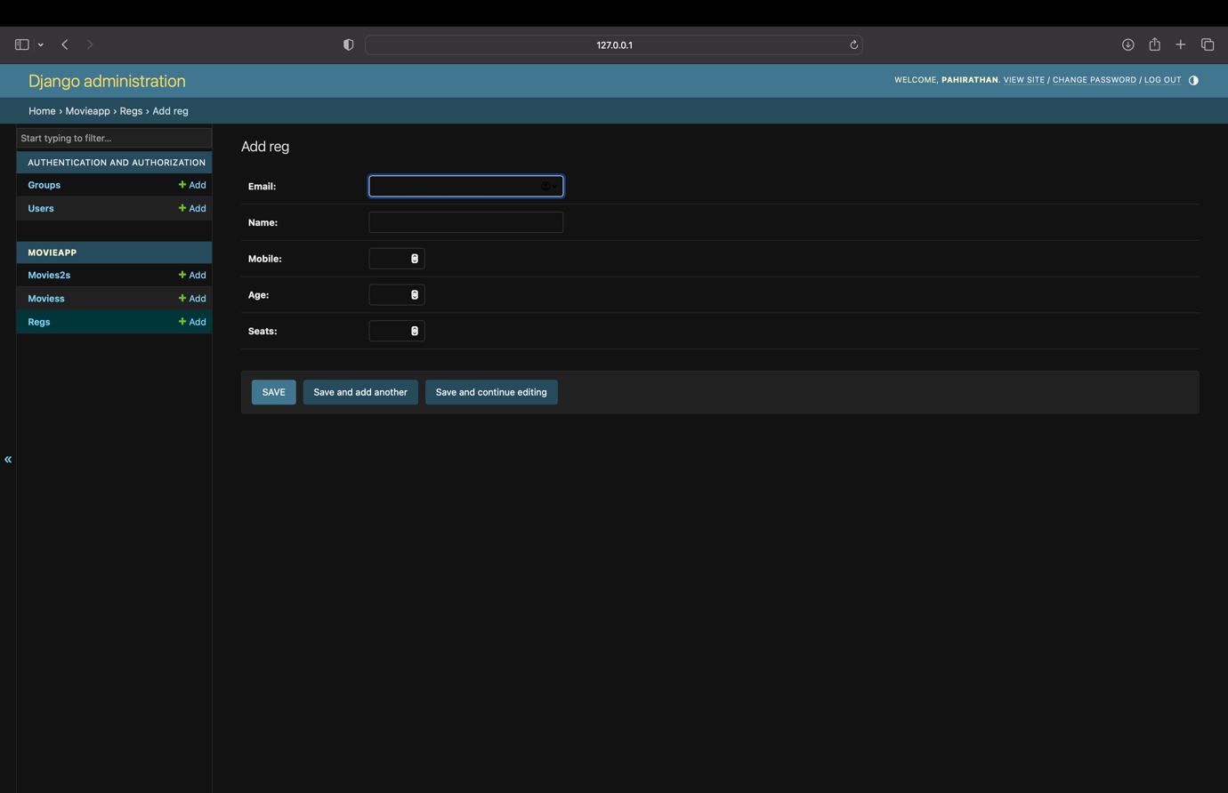

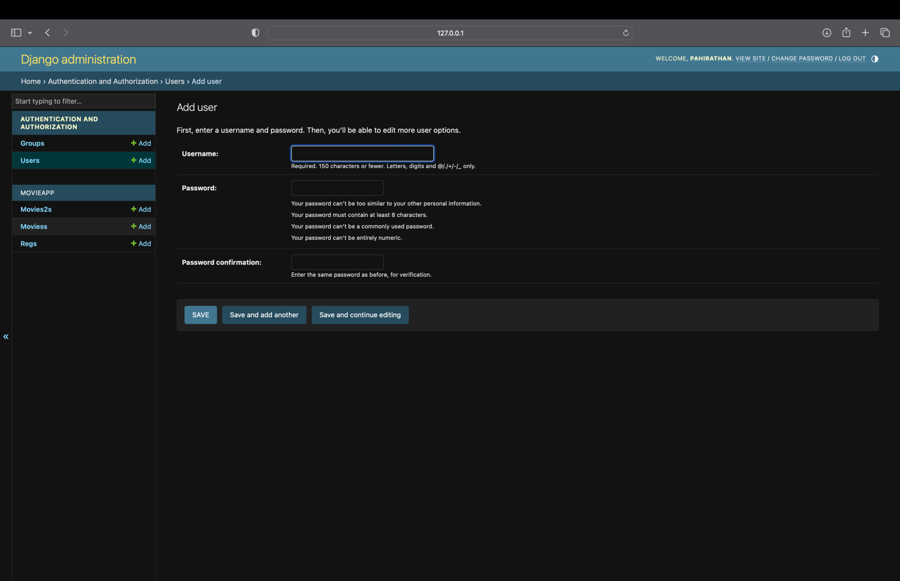

Thank You

P.Nithilan- Undergraduate BBSC (Hons) BPM